

|  |  |
| --- | --- |
| Student Name & Number | Anoop Mohanan Shyla ,10376354 |
| Course Title | MSc Information Systems with Computing |
| Lecturer Name | John Rowley |
| Module/Subject Title | Web and Mobile Technologies(B9IS122) |
| Assignment Title | Development of a Progressive Web Application (PWA) |

Introduction

The purpose of this assignment is to create a progressive web app that connects to a third partyAPI and handles offline and online access gracefully and uses local storage to handle offline activities.

Github Url:

Design Process

1. Home Page: On Home Page the user can view all the movie list, and also can select shows on different date and time.

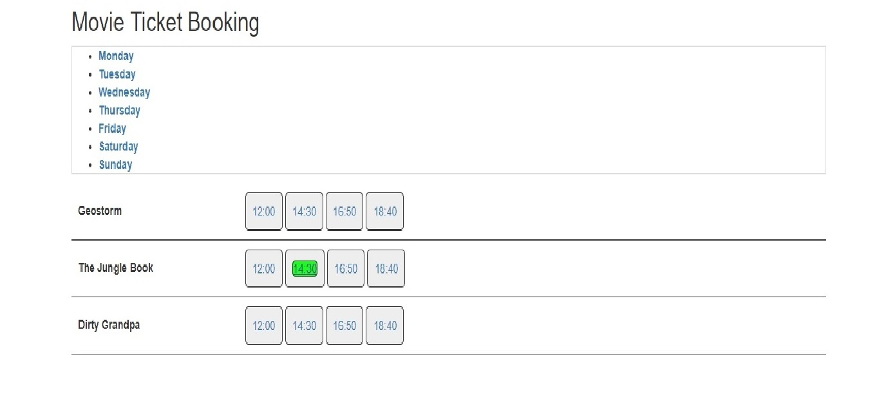

2.Seat Selection: Users can select seat location as there wish/availability.

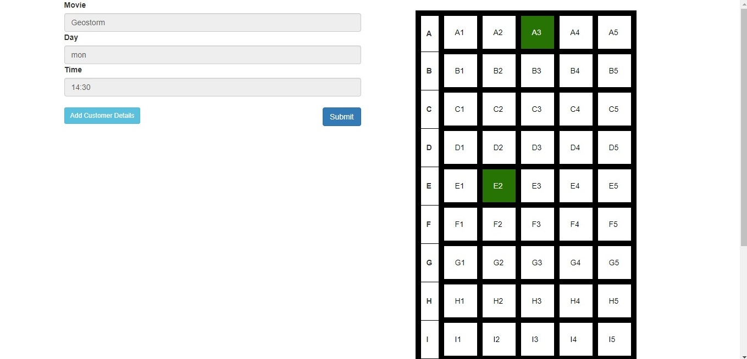

3.Add User Details: Name, Email, and Mobile number.

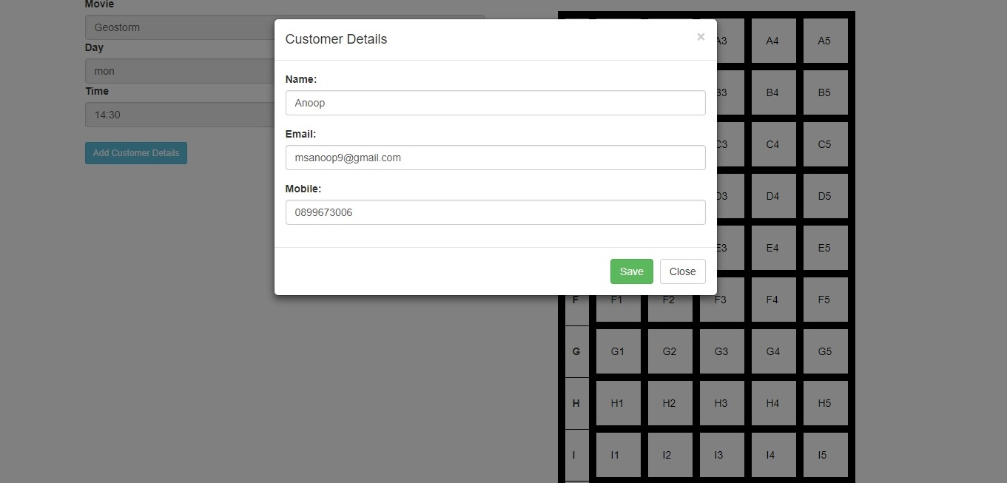

4.Booked page : where the customer can see booked show and details.

